WHICH UNIT TEST DO WE NEED TO SOLVE?

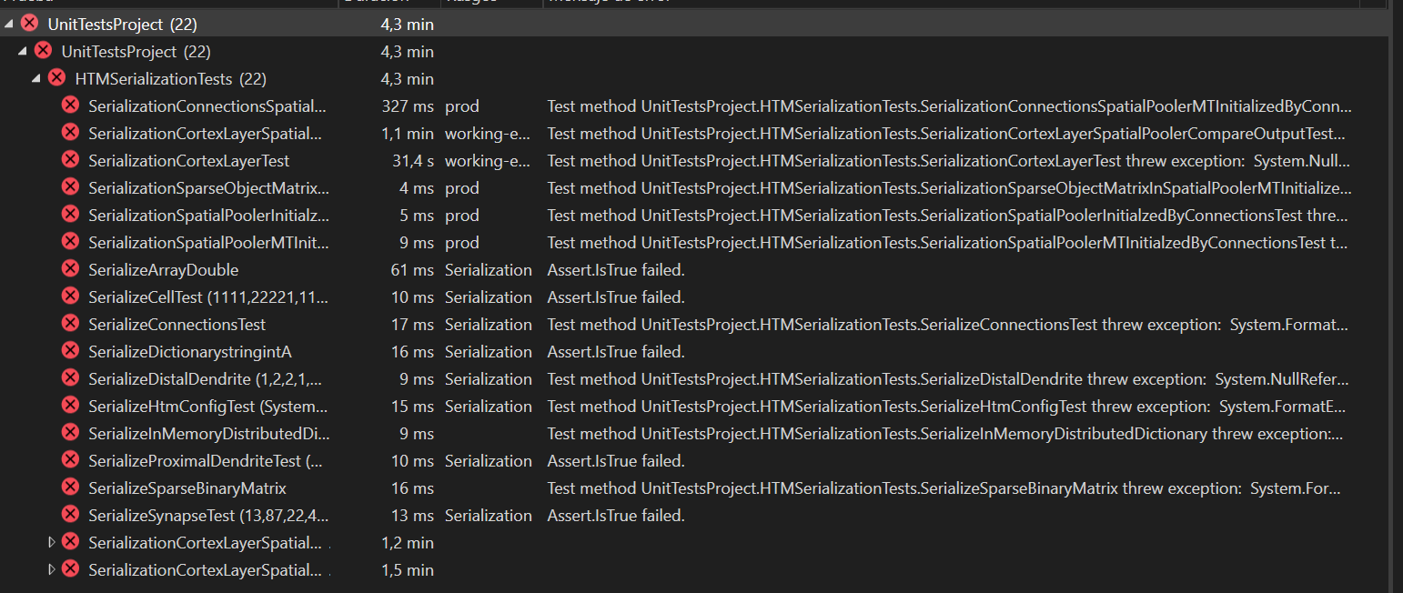

public void SerializeCellTest(int parentIndx, int colSeq, int cellsPerCol, int cellId)

PROBLEM: the parameter parent for our cell is not the same as cell1 so there is being an error in Assert.IsTrue when comparing the two cells



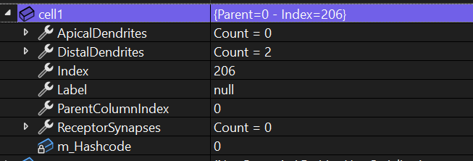 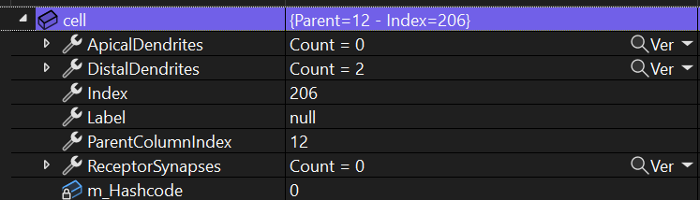

SOLUTION: the parameter parentIndx should be a 0 not a 12 as it was written

public void SerializeDictionarystringintA()

PROBLEM: Assert.IsTrue(keyValuePairs.SequenceEqual(keyValues));

The main problem is that when debugging it looks like both keyValues and keyValuePairs are indeed the same (pictures attached)

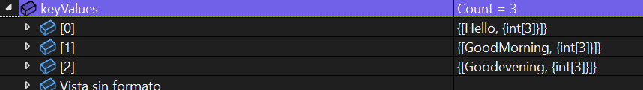

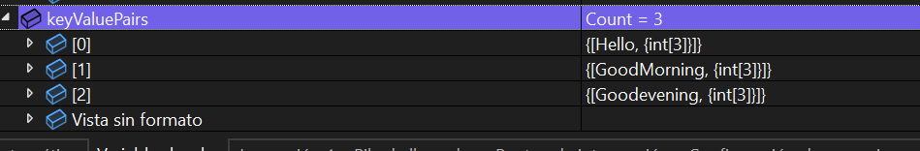

SOLUTION

public void SerializeArrayDouble()

PROBLEM: Assert.IsTrue(vs1.SequenceEqual(vs));





The problem is that after the method Trim() the value is 1.000 which the method Convert.ToDouble() is misreading. Instead of reading a number 1.0 is Reading a 1000.0.

We use the method Double.Parse with NumberStyles.Float and CultureInfo.InvariantCulture parameter to indicate that we are using a value which decimal part is indicated by a point and not a coma.

SOLUTION:



public void SerializeSynapseTest(int segmentindex, int synapseindex, double permanence)

PROBLEM: neither the parent or the permanence parameters are equal in both synapse. The Permanece problem is similar to one we had before; the program is reading the . not as a decimal but as a thousand value.

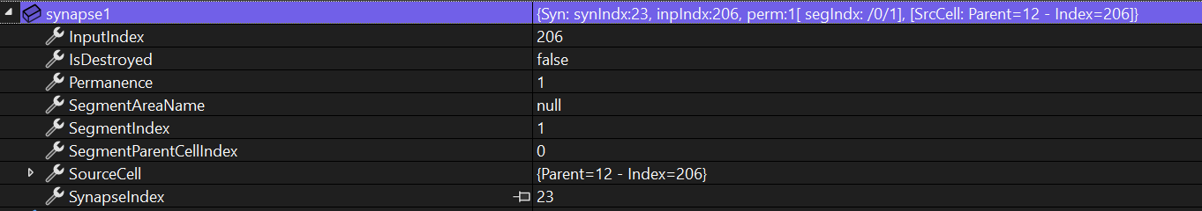

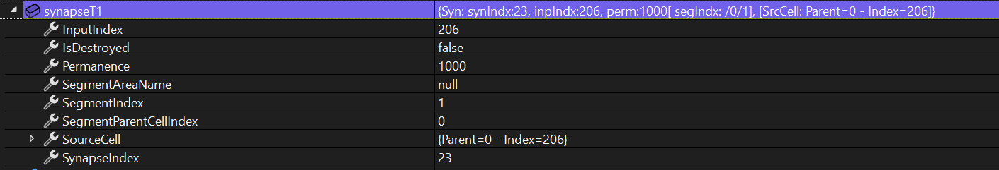

public void SerializationConnectionsSpatialPoolerMTInitializedByConnectionsTest()

PROBLEM: the object SegmentAreaName is set to null or not being initialized, so we are getting a NullReferenceException

SOLUTION: initialize SegmentAreaName